Optimizing Skin Cancer Detection in the USA Healthcare System Using Deep Learning and Convolutional Neural Networks

Author: JOHN SHIVOGO
Address: shivogojohn@gmail.com

Abstract
This research focuses on the intergration of Convolutional Neural Networks into skin cancer detection and an exploration of their potential implementation within the US healthcare system to optimize early detection.Integrating dermoscopic images, clinical data, and patient-reported information into Convolutional Neural Networks can lead to more accurate and timely skin cancer diagnosis and treatment.The findings of this research underscore the vital role that AI could play in assisting dermatologists and other healthcare professionals by delivering preliminary analysis and prioritizing high-risk cases, thereby optimizing and improving operational efficiency .This research concludes that further expansion of datasets to improve model generalization, integration of real-time imaging for faster diagnostics, and adoption of multi-modal techniques combining dermoscopic images with patient history for personalized skin cancer management is vital.These advancements aim to modernize dermatological care in the USA by increasing diagnostic precision, fostering earlier interventions and improving patient outcomes.

Keywords: Skin Cancer, Deep Learning, CNN, AI, USA Healthcare, Medical Imaging.

Introduction

Background and Motivation

In the USA healthcare system , early detection of skin cancer is a critical factor in improving survival rates and treatment outcomes, especially for patients with melanoma, basal cell carcinoma, and squamous cell carcinoma. Timely diagnosis significantly increases the likelihood of successful treatment, with melanoma, the deadliest type, being curable in over 90% of cases when detected early. This underscores the importance of early-stage identification to provide patients with effective and potentially life-saving interventions.

Currently, the main approaches to skin cancer detection include dermatological self-examinations and routine check-ups by healthcare professionals. These methods rely heavily on visible indicators, such as changes in moles or unusual skin growths, which make skin cancer among the most detectable malignancies. However, these traditional strategies have limitations in terms of accessibility, diagnostic consistency, and the potential for delays in detection and intervention.

Given these challenges, there is growing interest in leveraging artificial intelligence (AI) and advanced imaging technologies to enhance the accuracy and efficiency of skin cancer screening. AI-powered tools, such as deep learning algorithms and convolutional neural networks (CNNs), have shown promise in improving diagnostic sensitivity and specificity. These methods can assist healthcare providers in identifying skin lesions earlier and more accurately, potentially reducing diagnostic delays and improving patient outcomes

Study Objectives

The primary objective of this research is to leverage deep learning techniques to improve the detection of skin cancer in the USA healthcare system using dermoscopic images. By focusing on advanced image analysis, this study aims to address challenges in early and accurate diagnosis, which is crucial for effective treatment and patient outcomes.

Central to this work is the development of a convolutional neural network (CNN) model specifically designed for precise classification of skin cancer. The model will be trained and fine-tuned to differentiate between various types of skin lesions with a high degree of accuracy. This involves utilizing large datasets of dermoscopic images and employing state-of-the-art machine learning methodologies to ensure robustness and reliability.

Additionally, the study seeks to evaluate the performance of the CNN model in both experimental and clinical settings. Special attention will be given to assessing its potential for practical application in healthcare systems across the USA. By doing so, this research aims to contribute to the integration of AI-based tools in clinical practice, ultimately enhancing diagnostic precision and improving patient care.

Literature Review

Skin Cancer and its Detection in the USA

Skin cancer is the most prevalent type of cancer in the United States, encompassing three primary forms: basal cell carcinoma (bcc), squamous cell carcinoma (scc), and melanoma. Other common types include benign keratosis lesions(bkl), Melanocitic nevi(nv), Actinic keratoses(akiec), Vascular lesions(vasc) and Dermato fibroma(df).

Among these, BCC and SCC, collectively referred to as keratinocyte carcinomas, are the most common but are generally less likely to metastasize. In contrast, melanoma, though less common, accounts for the majority of skin cancer-related deaths due to its aggressive behaviour and high potential for metastasis. Approximately one in five Americans is expected to develop skin cancer by the age of 70. In 2024 alone, melanoma is projected to result in around 8,290 deaths, underscoring its severe health impact. Beyond the human cost, the economic burden is significant, with annual expenditures for the treatment of BCC and SCC surpassing $8.9 billion.

Current diagnostic methods for skin cancer rely on a combination of clinical evaluation and laboratory techniques. Physical examination and dermoscopy are among the primary approaches to diagnosing skin cancer . Traditional diagnosis typically begins with a dermatologist visually inspecting the skin, often supplemented by dermoscopy, a non-invasive imaging method that magnifies subsurface skin structures. Dermoscopy has been instrumental in improving diagnostic accuracy; however, its efficacy heavily depends on the clinician's expertise and training, which can vary considerably.

For a more definitive diagnosis, histopathology is the gold standard. This process involves taking a biopsy of the lesion, which is then analysed under a microscope. While histopathological examination provides highly reliable results, it is invasive, time-consuming, and resource-intensive. In cases of aggressive cancers like melanoma, delays in obtaining biopsy results can impede timely intervention, exacerbating patient outcomes.

In addition to procedural challenges, the United States faces notable resource constraints in dermatological care. Access to specialized healthcare providers is often limited in rural and under-served communities, leading to delays in both diagnosis and treatment. This disparity contributes to health inequities, as individuals in these regions are more likely to present with advanced-stage cancer at the time of detection.

Manual diagnostic methods also introduce subjectivity and labour intensity. Variability in interpretation among dermatologists can lead to inconsistent results, particularly when distinguishing between benign and malignant lesions. Furthermore, the reliance on human expertise limits scalability, especially in the face of an increasing prevalence of skin cancer cases. This growing demand places a strain on healthcare systems, emphasizing the need for more efficient and scalable diagnostic solutions.

These challenges highlight the critical need for advancements in skin cancer detection methods, including the integration of scalable, technology-driven solutions to address disparities and improve diagnostic accuracy.

Deep Learning in Medical Imaging

Deep learning, a specialized sub-field of artificial intelligence (AI), has revolutionized medical imaging by automating complex analyses and uncovering intricate patterns within large, complex datasets. This approach enables the development of highly accurate diagnostic models that significantly enhance the effectiveness of medical image analysis. Deep learning’s ability to process large volumes of data efficiently has made it particularly valuable in medical imaging applications such as skin cancer detection. By utilizing sophisticated algorithms, deep learning models can detect subtle patterns in images—such as dermoscopic photographs—enabling earlier and more accurate diagnoses that often surpass traditional methods by minimizing human error and subjectivity.

Convolutional Neural Networks (CNNs), a cornerstone of deep learning in medical imaging, have demonstrated remarkable success in the detection of skin cancer. CNNs excel in classifying skin lesions and identifying pathologies, such as melanoma, basal cell carcinoma (BCC), and squamous cell carcinoma (SCC), by analysing dermoscopic images. Previous studies show that CNNs can achieve diagnostic accuracy comparable to or even exceeding that of experienced dermatologists. For example, CNNs have been trained on large datasets like the HAM10000, which contains thousands of labelled images, enabling the model to learn the subtle visual cues that differentiate malignant from benign lesions.

These models are particularly beneficial in regions with limited access to dermatological expertise, as they can automate routine image analysis and help prioritize high-risk cases, thus alleviating the burden on healthcare professionals. Moreover, CNNs have shown excellent performance when combined with transfer learning, where pre-trained models, such as ResNet and VGG, are fine-tuned on specific skin cancer datasets. This approach not only improves the model’s ability to generalize across various datasets but also reduces the time and computational resources needed for training.

Studies have consistently highlighted the potential of CNNs to enhance diagnostic accuracy and efficiency, making them a valuable tool in skin cancer detection and advancing the field of medical imaging overall.

Convolutional Neural Networks (CNNs)

Convolutional Neural Networks (CNNs) are a powerful class of deep learning models specifically designed to process grid-like data, such as images. The architecture of CNNs comprises several key components that contribute to their effectiveness in image classification tasks. At the core of CNNs are convolutional layers, which apply filters to input images to extract feature maps. These filters are designed to identify fundamental patterns like edges, textures, and shapes, which are essential for recognizing visual elements in an image. Pooling layers follow, reducing the spatial dimensions of these feature maps while preserving the most crucial information. This process helps lower computational requirements and enhances the efficiency of the network. The final component is the fully connected layers, which use the extracted features to classify the image into specific categories, such as distinguishing between different types of skin lesions. This hierarchical feature extraction—starting from basic patterns and progressing to more complex representations—enables CNNs to learn from raw pixel data and recognize intricate visual patterns. As such, CNNs are particularly well-suited for medical imaging tasks like skin cancer detection, where the ability to identify subtle features in images is paramount.
CNNs are highly relevant in skin cancer classification due to their ability to detect visual differences between benign and malignant lesions. For instance, they can identify key features such as asymmetry, irregular borders, and colour variation, which are important indicators of malignancy in skin lesions. CNNs are also capable of learning and optimizing feature representations automatically, eliminating the need for manual feature engineering. This not only reduces the potential for bias but also improves diagnostic consistency, making them a more reliable tool compared to traditional diagnostic methods.
Recent advancements in CNN technology include the development of attention mechanisms, which help focus the model's processing power on the most diagnostically relevant regions of an image. In the case of skin cancer detection, this may involve highlighting atypical areas of a lesion that require further attention. Additionally, tools such as heatmaps, have been introduced to help clinicians understand how the model arrives at its predictions. These tools enhance trust in AI-driven diagnostics by providing transparency and allowing healthcare professionals to see which parts of an image influenced the model's decision-making.
Notable CNN architectures, such as ResNet and Inception, have been specifically adapted for skin cancer detection due to their depth and ability to learn complex features without overfitting. These models excel at analysing dermoscopic images, identifying small yet critical features indicative of skin cancer. Another major development in the application of CNNs for skin cancer detection is the use of transfer learning. Pre-trained models, such as VGG16 and EfficientNet, are fine-tuned using specialized dermoscopic image datasets. This approach reduces training time and improves the model’s performance, especially when working with smaller, specialized datasets. By utilizing knowledge learned from large, diverse datasets, transfer learning helps the model generalize better across different types of images and enhances its accuracy in detecting skin lesions.
Finally, CNNs are increasingly being integrated into clinical practice, particularly through telemedicine platforms. These platforms enable remote diagnosis and triaging of suspicious lesions, providing scalable and cost-effective solutions to address healthcare disparities, especially in under-served regions. CNNs assist dermatologists by prioritizing high-risk cases, streamlining the workflow, and reducing their overall workload. This clinical integration not only optimizes diagnostic efficiency but also ensures that patients in remote areas receive timely care, thus addressing critical gaps in access to specialized healthcare.
These advancements in CNN technology, including their application in skin cancer detection and integration into clinical workflows, highlight the transformative potential of deep learning in medical imaging and healthcare.

Data Collection and Preprocessing

Data Sources

The HAM10000 ("Human Against Machine with 10000 training images") dataset is a comprehensive collection of 11,114 dermoscopic images specifically designed for the detection of pigmented skin lesions. It has become one of the most widely utilized resources for training and evaluating machine learning models aimed at skin cancer detection. The dataset features a diverse range of images that are categorized into seven diagnostic classes, including melanoma (mel), basal cell carcinoma (bcc), benign keratosis lesions (bkl), melanocytic nevi (nv), actinic keratoses (akiec), vascular lesions (vasc), and dermatofibroma (df). This categorization allows researchers to apply various machine learning techniques for lesion classification, segmentation, and automated diagnosis, contributing significantly to the advancement of AI-based diagnostic tools in dermatology.

One of the key characteristics of the HAM10000 dataset is its diversity. The images were collected from multiple sources, incorporating different imaging modalities and populations, which ensures that the dataset represents a wide variety of skin types and conditions. This diversity is crucial for training models that can generalize across different patient demographics and skin characteristics. Additionally, diagnostic validation is an integral aspect of the dataset. For more than half of the cases, diagnoses were confirmed through histopathology, while the remaining cases were validated through expert consensus, follow-up exams, or in-vivo confocal microscopy. This robust validation process ensures the accuracy and reliability of the dataset, making it an invaluable resource for machine learning applications in medical imaging.

The HAM10000 dataset serves as a benchmark for various tasks such as lesion classification and segmentation, facilitating the development of automated diagnosis systems that can improve the accuracy and efficiency of skin cancer detection. The dataset is publicly available for non-commercial use on platforms such as Kaggle and Harvard Dataverse, making it accessible to researchers and developers working in the field of medical image analysis.
Ethical Considerations and Compliance
Given the sensitive nature of medical data, ethical considerations are paramount when handling datasets like HAM10000. To ensure patient privacy and confidentiality, data handling adheres to strict regulations, including HIPAA compliance. Identifiable information within the dataset is either removed or anonymized, safeguarding the privacy of the individuals represented in the images. Furthermore, the dataset is provided under terms that restrict its use to academic and non-commercial purposes, preventing potential exploitation for commercial gain. Users of the HAM10000 dataset are also required to acknowledge the original dataset creators and publications, ensuring transparency and ethical use of the resource. These ethical measures promote responsible handling of sensitive medical data and foster trust in the research community.

Data Preprocessing

Data preprocessing is a critical preliminary step in this research, aimed at ensuring accuracy and maintaining the quality of data for predictive modelling in healthcare. Proper preprocessing is vital for preparing the data to be effectively utilized by deep learning algorithms, which can be highly sensitive to inconsistencies and missing values.For the CNN model used for this research, the prevalent preprocessing step implemented is Data Augmentation
Data augmentation
Data augmentation was applied to reduce overfitting and improve the model’s ability to generalize across unseen data.Data augmentation techniques employed include rotation and horizontal flipping, zoom and shift transformations, shear transformations, fill mode with noise simulation
In Rotation and Horizontal Flipping , images were rotated up to 30 degrees and flipped horizontally to minimize orientation-specific biases, ensuring the model could recognize features regardless of their orientation.Applied zoom and positional shifts allowed the model to adapt to scenarios where the lesion or tumour might not be centrally positioned in the image, making it better equipped for non-standard clinical images.Shear Transformations introduced geometric distortions, encouraging the model to identify relevant features under skewed perspectives.For Fill Mode with Noise Simulation the nearest fill mode handled areas of the image altered by transformations, simulating natural variations in imaging conditions, further enhancing model resilience.

Exploratory Data Analysis (EDA)
Exploratory Data Analysis (EDA) is primarily conducted to gain a deeper understanding of the dataset, guiding the data preprocessing steps and informing model selection. This process typically involves several methods, particularly visual and statistical assessments of the data.
Statistical Summary
The skin cancer dataset comprises various features extracted from dermoscopic images, such as mean intensity, standard deviation of intensity, aspect ratio, and file size. Descriptive statistics have been employed to analyse the spread of these values and identify outliers within the dataset. Examining these image properties provides critical insights into the differences between healthy skin and skin affected by various types of cancer.
The dataset's summary statistics include metrics such patient as image dimensions, pixel intensity distributions, and texture characteristics across different cancer types. These metrics quantitatively describe variations in lesion size, shape, and intensity patterns. The analysis highlights the variability among classes, offering a foundation for distinguishing between benign and malignant lesions and supporting the CNN model's ability to classify skin cancer effectively.
Visual Analysis Of The Distributions
In the context of skin cancer detection, visual analysis of class distribution plays a crucial role in understanding dataset characteristics and guiding the model development process. Class distribution often reveals important insights about the dataset, especially in medical imaging, where class imbalances can significantly impact the performance of machine learning models.
In the Skin Cancer Dataset, the "nv" (Melanocytic nevi) class accounts for over 60% of the total images, whereas other classes, such as "vasc" (vascular lesions), "df" (dermatofibroma), and "akiec" (actinic keratoses), represent less than 3% of the dataset(see Figure 1). This imbalance presents a challenge during model training, as it can cause the model to become biased towards the dominant class, resulting in less accurate predictions for the under-represented classes.

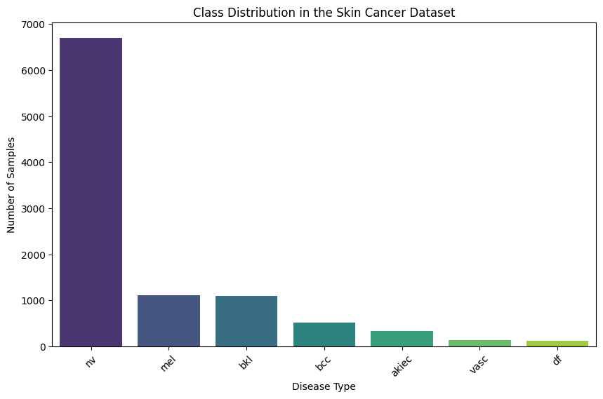
Figure 1. The bar plot illustrates the number of samples of each category of skin cancer in the dataset.
Histopathology is the most common type of medical diagnosis performed on the skin cancer patients in this dataset(see figure 2). This is mainly because histopathy is considered the definitive method for diagnosing skin cancer and allows for clear, detailed examination of cellular structures.In many cases Histopathology accrues a very high accuracy where other diagnosis methods are inconclusive and for this reason it is often used for confirmation.Confocal diagnosis is relatively newer technology, it is more often used in research settings and specialized clinics but less common in routine clinical practice due to the high cost involved, specialized equipment requirements, and the need for trained professionals.
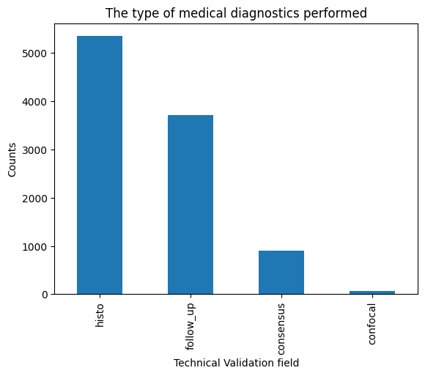
Figure 2. The bar plot illustrates the distribution of medical diagnosis performed on the skin cancer patients.
From the skin cancer dataset the body parts most susceptible to cancer are the back and lower extremities this is probably because these are the largest and most exposed areas of the body to UV radiation(see Figure 3).The acral skin is the body part least susceptible to skin cancer as it has a thicker keratinized layer that provides additional barrier to UV radiation and other carcinogens that may contribute to skin cancer.Other body parts such as the neck, scalp, hand,ear and genital are at a much lower risk of contracting skin cancer because they are less exposed to causative agents.

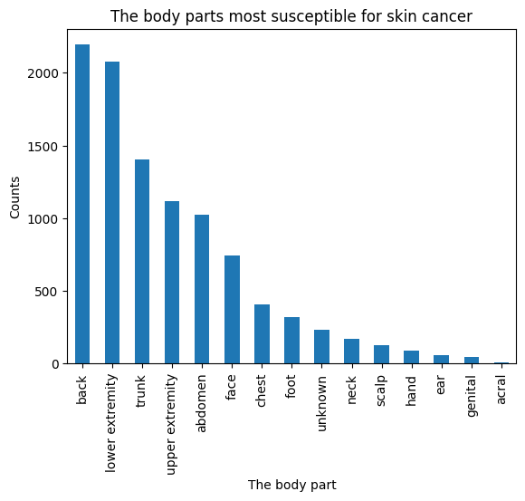

Figure 3. The bar plot showcases the body parts most susceptible to cancer based on patient data.
From the diagnosed patients, the level of skin cancer increases exponentially between the ages of 5 and 45 then diminishes between the ages of 50 and 85(see Figure 4). This may be due to the fact that people of ages 5-45 spend most of the times outdoors exposed to UV rays and between the ages 50-85 there is reduced outdoor activity and also at this age there is a high mortality rate where fewer people live long enough to develop late-stage skin cancer for diagnosis.

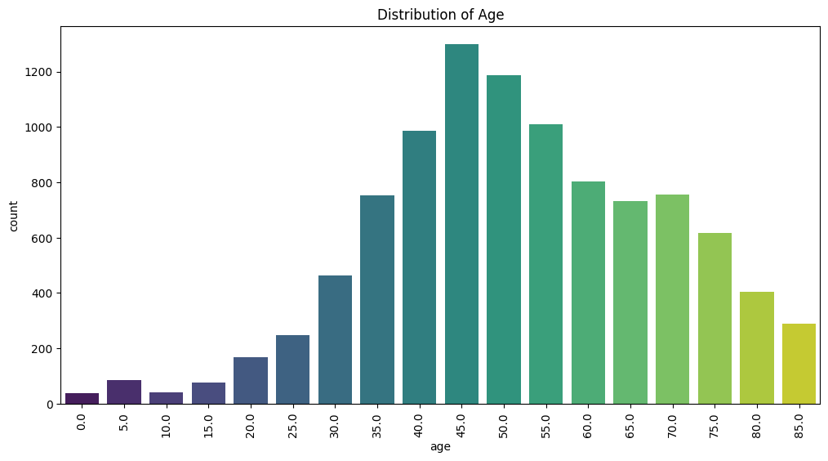
Figure 4. The countplot illustrates the distribution of cancer patients by age.
It is also observed that the number of men diagnosed with skin cancer is a little bit higher than the female counterparts(see Figure 5). The disparity is quite minimal and may be due to occupational exposure, leisure and recreational exposure.Beauty standards for women in societies has them taking care of themselves and their skin more than men do. Also, men tend to develop melanoma more often than women particularly on the back and chest.

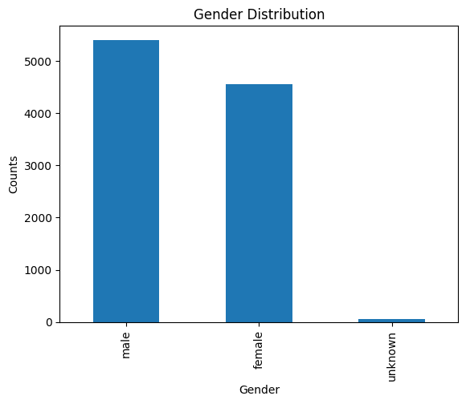
Figure 5. The bar plot illustrates the distribution of cancer patients by gender.

Analysis Of Skin Cancer Images
Skin cancer types in the dataset exhibit various key differences in terms of colour, shape, and size, which CNN models consider when classifying images into their respective categories(see Figure 6). Melanoma (mel) skin cancer is asymmetrically shaped, with irregular borders that often have notched or scalloped edges. Its colours vary, including shades of brown, black, tan, red, white, or blue, and its diameter is usually larger than 6 millimetres. This type often shows changes in size, shape, colour, or elevation over time.
Basal Cell Carcinoma (bcc) commonly appears as a shiny, pearly bump or nodule that can be flesh-coloured, pink, red, or brown. It may resemble a sore that bleeds, crusts, heals, and then reopens. Additionally, it can present as a flat, scaly area prone to bleeding. Actinic Keratosis (acc) typically manifests as rough, scaly patches on sun-exposed areas like the face, scalp, ears, or hands, and can be flesh-coloured, pink, red, or brown.
Benign Keratosis-like Lesions (bkl) share similarities with Actinic Keratosis in appearance but are generally benign, meaning they are not cancerous and do not spread to other body parts. Dermatofibroma (df) is a firm, dome-shaped cancer type that can appear brown, flesh-coloured, or red. It is usually painless but may become irritated or itchy.
Melanocytic Nevi (nv) are brown or black in colour, round or oval in shape, and smooth-surfaced. They are generally harmless. Vascular Lesions (vasc) can appear as red, purple, or blue spots, bumps, or patches. While most vascular lesions are benign, some may require further evaluation.

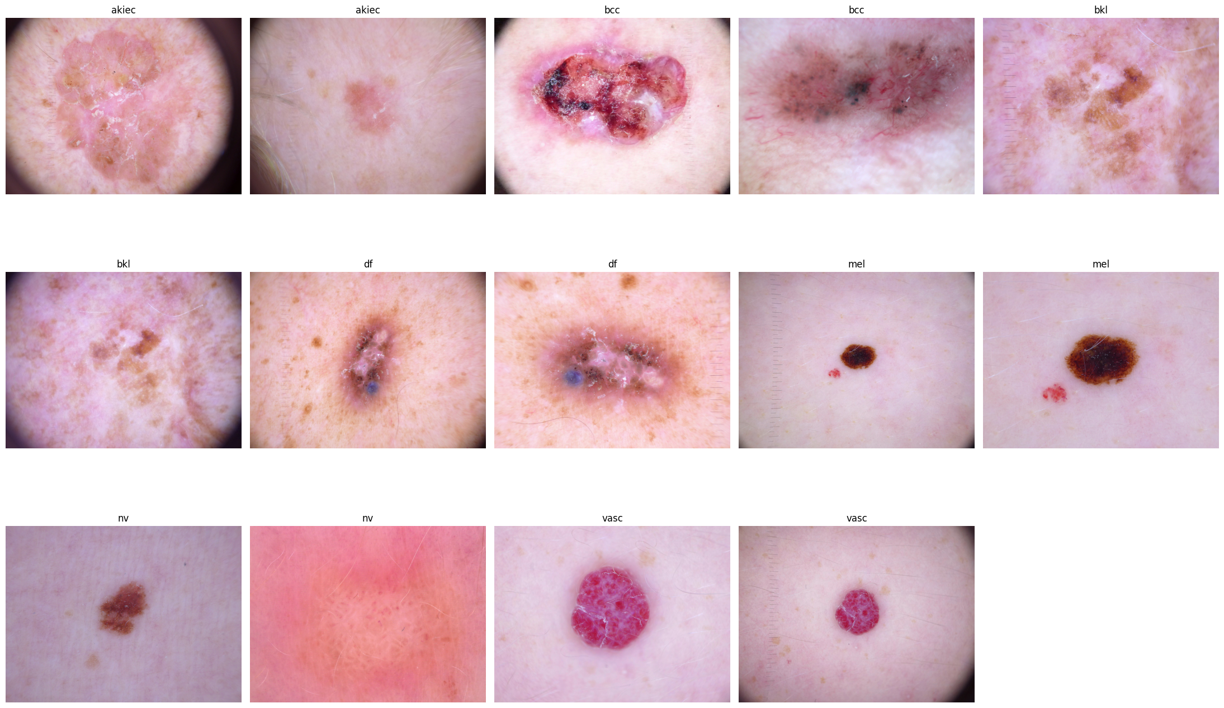
Figure 6. Representative images from the skin cancer dataset illustrate the visual differences between the 7 categories of skin cancer

Image Quality Analysis and visualizations

Each image in the dataset was carefully assessed for sharpness and contrast to ensure that critical details, such as skin lesion boundaries and textures, were well-defined. Low-quality images, characterized by insufficient brightness or high noise levels, were flagged for re-examination. If the quality of these images would likely compromise the model’s performance, they were discarded from further analysis. This step ensures that only high-quality data contributes to model training, leading to more accurate and reliable predictions.

The images in the dataset appear to have very similar dimensions, with a width of around 600 pixels and a height of around 460 pixels(see Figure 7). This suggests a high degree of consistency in the image acquisition process.The aspect ratios for all images were found to be consistent, indicating that the images had been standardized to uniform dimensions before being fed into the model. Consistency in aspect ratio ensures that the model can focus on the relevant features of the images without being distracted by size or resolution discrepancies.The file size distribution shows a wide range, suggesting that images in the dataset may have varying levels of compression or resolution.The large variation in file size could be an opportunity for optimization. By compressing images without significant loss of quality, the dataset size can be reduced, leading to faster training and deployment

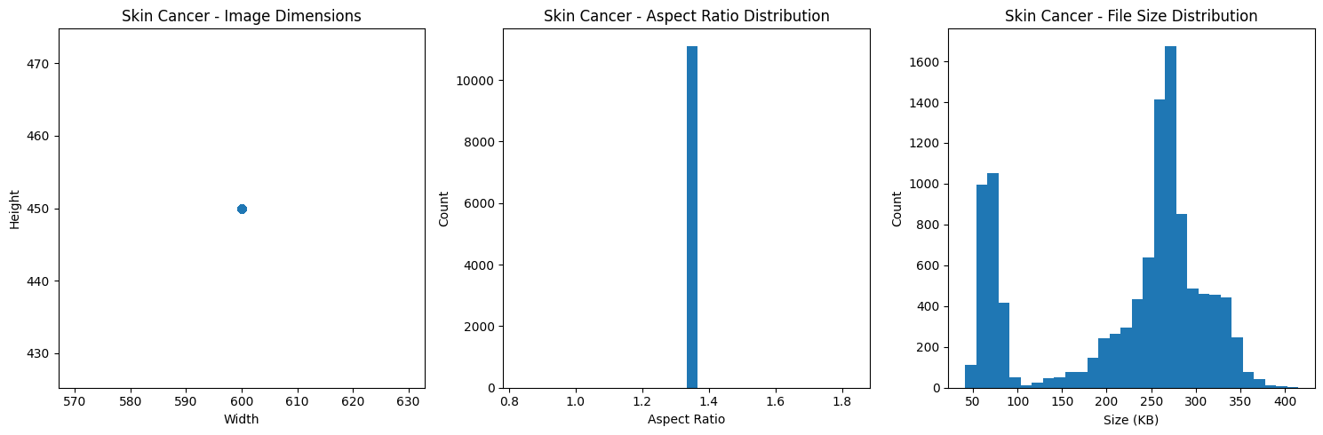
Figure 7. The plots illustrate the distribution skin cancer image properties such as image dimensions, aspect ratios and file size distributions

Pixel Intensity Distribution and Enhancement
The distribution of pixel intensities across images was analysed using histograms(see Figure 8). This allowed for the identification of skewed intensity distributions, which often indicate poor image quality or the presence of artefacts. In cases where the intensity distribution was found to be uneven, image enhancement techniques were applied to uniformly adjust the brightness and contrast. These techniques are essential to standardize the images and ensure that the model can learn from consistent features across all images.

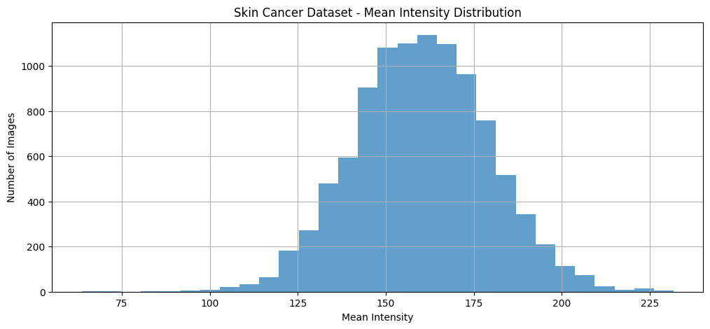

Figure 8. The histogram represents the distribution of mean pixel intensity, showing a broad range and diverse brightness levels among the images.

RGB histograms are graphical representations of the intensity distribution for the red, green, and blue colour channels within a dataset of dermoscopic images. These histograms provide insight into the colour composition of skin lesions and their surrounding tissue. In skin cancer detection, such as differentiating between melanoma, basal cell carcinoma (bcc), or benign keratoses (bkl), these histograms reveal the variations in pigmentation, texture and structural composition. Peaks in specific colour channels reflect the lesion's pigmentation and vascular properties(see Figure 9)

The red channel often highlights areas of vascularization, inflammation, or blood presence.The blue channel emphasize pigmentation associated with deeper tissue structures or necrotic areas.The green channel balances the contrast and is associated with skin texture and lighter pigmentation.

Melanoma images exhibit a wider range of pixel intensities, particularly in the red channel, indicating diverse color presentations, including brown, black, red, and white. Benign Keratosis-like Lesions (bkl) and Actinic Keratosis (akiec) images share a similar distribution, peaking in the lower intensity range, suggesting lighter skin tones. Basal Cell Carcinoma (bcc) images, on the other hand, peak in the higher intensity range, indicating darker or reddish tones. Vascular Lesions (vasc) images show a peak in the red channel, reflecting their red or purple appearance. Melanocytic Nevi (nv) images, while similar to melanoma, tend to have a lower frequency of high-intensity pixels. Dermatofibroma (df) images also exhibit a peak in the lower intensity range, aligning with bkl and akiec.

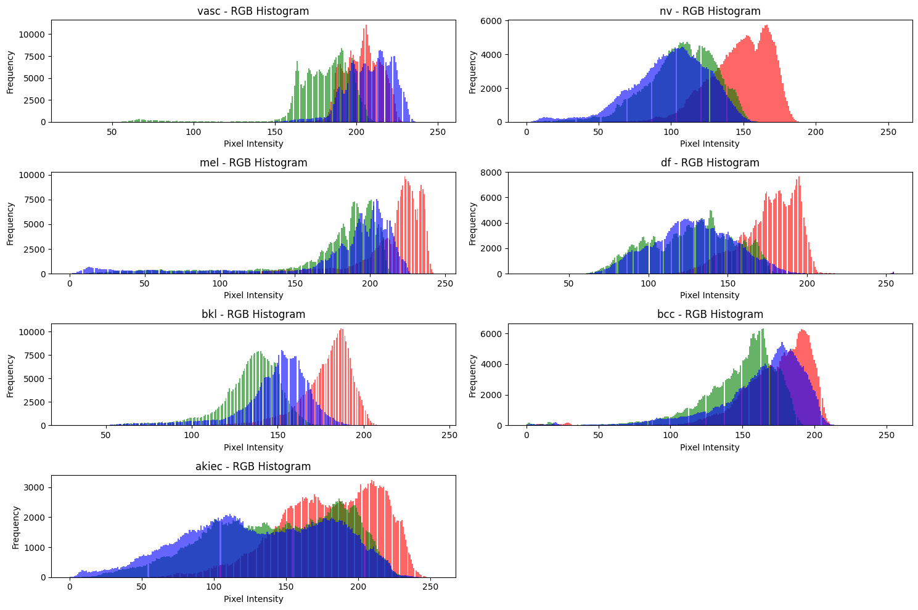
Figure 9. The RGB histograms display pixel intensity distributions across the red, green, and blue channels for different skin cancer types, indicating differences in color composition and tissue characteristics.
Class Distribution in the Skin Cancer Dataset
The skin cancer dataset consists of a total of 11,114 images, with the Vascular lesion making up 1.28% of the image dataset, Melanocytic nevi makes up 60.33% of the dataset , mel (Melanoma) makes up 10.01% of the dataset, Dermatofibroma makes up 1.03%, Benign keratosis-like lesions makes up 9.89%, Basal cell carcinoma makes up 4.62% and Actinic keratoses intraepithelial carcinoma makes up 2.94% if the image dataset(see Figure 10).
The class distribution shows a high imbalance, with the "nv" class comprising more than 60% of the images, while other classes, such as "vasc," "df," and "akiec," have very few images. This imbalance requires careful consideration when designing a model to prevent bias toward the majority class (nv).
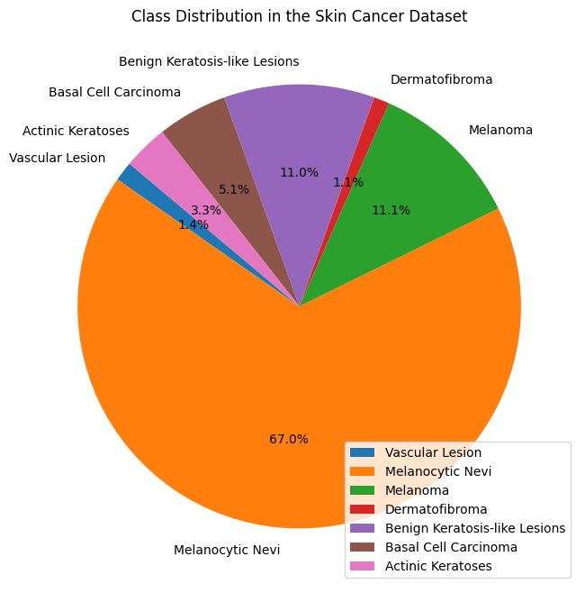
Figure 10. Class distribution of the skin cancer dataset.
Class-Balanced Distribution and Resampling
Due to the imbalance in class distribution, a class-balanced approach was necessary for training. While some datasets might require resampling techniques (like oversampling the minority class or undersampling the majority class), this dataset's imbalance is manageable with the use of class weights during model training. Class weights help prevent the model from favoring the dominant class (nv) and ensure that the minority classes are given appropriate attention.
Outlier Detection and Statistics
To prepare the dataset for training, we calculated the average aspect ratio, mean, and standard deviation of pixel intensities across the images. This statistical analysis helped identify any outliers that might skew the training process. Images with extreme pixel intensity values or unusual aspect ratios were flagged and removed to maintain the integrity of the dataset.

Methodology

Model Architecture

The Convolutional Neural Network (CNN) architecture employed in this study consists of several key components tailored for medical image classification, particularly for detecting and categorizing skin cancer. The architecture integrates various building blocks namely: Convolutional layers, Activation Layers, Pooling Layers, fully connected layers and an output layer.
Convolutional Layers extract features from input images by applying convolutional kernels across the spatial dimensions. These operations identify local patterns such as edges, textures, and shapes critical for distinguishing between different skin cancer types. Multiple convolutional layers are stacked to learn hierarchical features, starting with basic patterns and progressing to complex lesion structures.
The Rectified Linear Unit (ReLU) activation function introduces non-linearity to the model, enabling it to learn complex relationships in the data. ReLU is computationally efficient and mitigates issues like vanishing gradients during training, making it ideal for deep architectures.
Max-pooling operations are used to reduce the spatial dimensions of feature maps while retaining the most critical information. This not only speeds up computation but also helps prevent overfitting by simplifying the feature space. A kernel size of 2x2 with a stride of 2 is typically applied.
The final layers are fully connected (dense) layers that consolidate features from the convolutional and pooling layers to make predictions. Each neuron outputs probabilities for each class (e.g., melanoma, benign keratosis), determined using a softmax activation function.
For this multi-class classification problem, the output layer uses a softmax activation to assign probabilities to each of the seven classes in the dataset.

The architecture for the CNN was selected and utilized due to several key advantages. CNNs are highly suitable for image classification, serving as the gold standard for image analysis because of their ability to automatically learn and optimize feature representations directly from pixel data. This eliminates the need for manual feature extraction, ensuring that subtle differences critical for medical diagnoses are effectively captured.
The hierarchical feature extraction capabilities of CNNs further enhance their effectiveness. The layered structure enables the model to progressively extract and refine features, beginning with basic elements such as edges and advancing to more abstract, domain-specific patterns like lesion asymmetry or irregular borders. This makes CNNs particularly well-suited for skin cancer classification, where such patterns hold significant diagnostic importance.
Scalability is another advantage, especially when transfer learning is applied. Pre-trained architectures such as ResNet and VGGNet improve CNN performance when dealing with imbalanced or limited datasets. These models come equipped with robust feature detectors, reducing the need for extensive training from scratch.
Additionally, optimization techniques play a crucial role in enhancing the architecture. The use of dropout layers helps reduce overfitting by randomly deactivating neurons during training. Batch normalization stabilizes learning and accelerates convergence by normalizing layer inputs. Finally, the Adam optimizer is employed for its adaptive learning rates, striking a balance between fast convergence and accuracy.

Training and Testing Framework

A comprehensive training and testing framework ensures model robustness and generalization. In this study, the dataset of skin cancer images was divided into three subsets: training, validation, and testing, to maintain a structured and unbiased evaluation process. The training set, comprising 80% of the data, was used for the model to learn patterns and adjust weights during backpropagation. A validation set, constituting 10% of the data, was employed to fine-tune hyperparameters and monitor performance after each training epoch. Lastly, the testing set, accounting for 10% of the data, remained entirely independent and was reserved for evaluating the model’s final accuracy and robustness. This splitting strategy ensured that the model generalized well to unseen data while maintaining an unbiased assessment.

Additionally, preprocessing steps were integral to preparing the dataset for effective training. Images were resized uniformly to 224x224 pixels to maintain a consistent input size. Normalization was performed, scaling pixel values to the range [0, 1], which improved convergence and training stability. Furthermore, image augmentation techniques such as horizontal flipping, random rotation, and zooming in/out were applied to diversify the dataset and reduce overfitting. This workflow ensured that the model was trained on a varied and representative dataset, enhancing its reliability and performance on unseen data.

Hyperparameter Tuning

Hyperparameter tuning is a crucial process for optimizing the performance of deep learning models, particularly complex ones like Convolutional Neural Networks (CNNs) for tasks such as skin cancer detection. In this study, key hyperparameters were systematically adjusted to enhance the model's accuracy and efficiency. The number of epochs was set to range between 20 and 50, allowing the model sufficient time to learn patterns without overfitting. Batch sizes were varied between 16 and 64, balancing memory usage and training efficiency.

Additionally, early stopping was implemented, with a patience level of 3 epochs to prevent overtraining. This strategy halted training when no significant improvement was observed in validation performance, ensuring computational efficiency and avoiding unnecessary adjustments. These carefully tuned hyperparameters were evaluated based on the validation set metrics, and the improvements were further validated on reserved datasets to ensure they generalized well to new, unseen data.

Evaluation Metrics

A CNN model's effectiveness in skin cancer detection is assessed using a comprehensive set of metrics to ensure accuracy, sensitivity, and reliability. Accuracy measures the proportion of correct predictions made by the model, calculated as the number of true positives and true negatives divided by the total predictions. While accuracy provides an initial measure of model efficacy, it can be misleading in cases of class imbalance, where the majority class dominates predictions. Hence, additional metrics like precision, recall, and F1-score are employed to gain a finer understanding of the model's performance.

Precision evaluates the ratio of true positive predictions to all positive predictions made by the model. In skin cancer detection, high precision ensures that when the model predicts a lesion as malignant, it is highly likely to be correct, reducing unnecessary interventions caused by false positives. Recall, or sensitivity, measures the proportion of actual positives correctly identified by the model. This is particularly critical in medical diagnoses, such as melanoma detection, where missing malignant cases can have severe consequences.

The F1-score, calculated as the harmonic mean of precision and recall, balances these two metrics and is especially useful in imbalanced datasets. A high F1-score indicates an effective trade-off between minimizing false positives and false negatives, making it a vital metric in medical domains. The confusion matrix further complements these metrics by providing a detailed tabulation of true positives, true negatives, false positives, and false negatives, offering a clear picture of the model's predictive capabilities.

When compared to baseline models, such as Support Vector Machines (SVM) or Decision Trees, CNNs consistently outperform in image-based tasks due to their ability to learn hierarchical features directly from raw image data. Studies have demonstrated CNNs achieving accuracy scores above 0.90, with transfer learning significantly enhancing diagnostic performance. In fact, fine-tuned CNNs have been shown to surpass dermatologist-level accuracy in detecting skin lesions, making them an indispensable tool in medical imaging and diagnostics.

Results

Model Performance

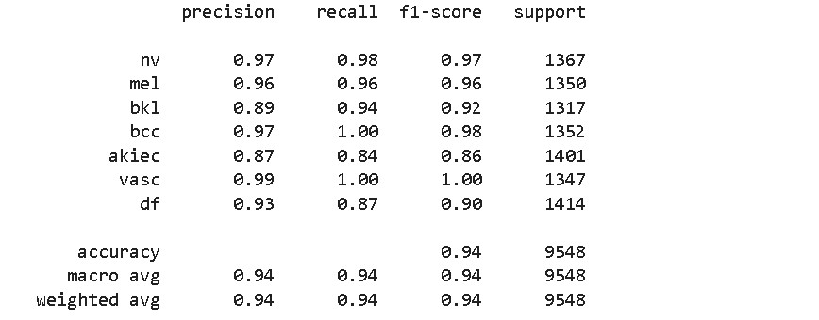
Figure 11. Classification report for the skin cancer CNN model
The performance of the CNN model was assessed using various metrics, including accuracy, precision, recall, and F1-score, to evaluate its effectiveness across different classes in the dataset(see Figure 11). The model achieved an overall accuracy of 94.17%, with a macro average precision, recall, and F1-score of 0.94. Similarly, the weighted averages for these metrics were also 0.94, indicating consistent performance across the dataset.
These results highlight that the model demonstrated high precision and recall for most classes, particularly for vascular lesions (vasc), basal cell carcinoma (bcc), and melanoma (mel). However, the class representing actinic keratoses and intraepithelial carcinoma (akiec) exhibited slightly lower recall, suggesting that the model struggled more to correctly identify cases in this category. This indicates potential areas for improvement in further refining the model's ability to distinguish akiec from other classes.

Visualisation Of Accuracy and Loss Curves
The accuracy and loss curves plot the model’s performance over the training epochs. The accuracy curve indicates how well the model is correctly classifying the images, while the loss curve shows how well the model is minimizing error during training. Both curves were monitored to ensure the model did not overfit or underfit during training.
The accuracy curve steadily increases, indicating that the model is learning effectively over time whereas the loss curve decreases, suggesting the model's ability to minimize prediction error as it trains(see Figure 12).
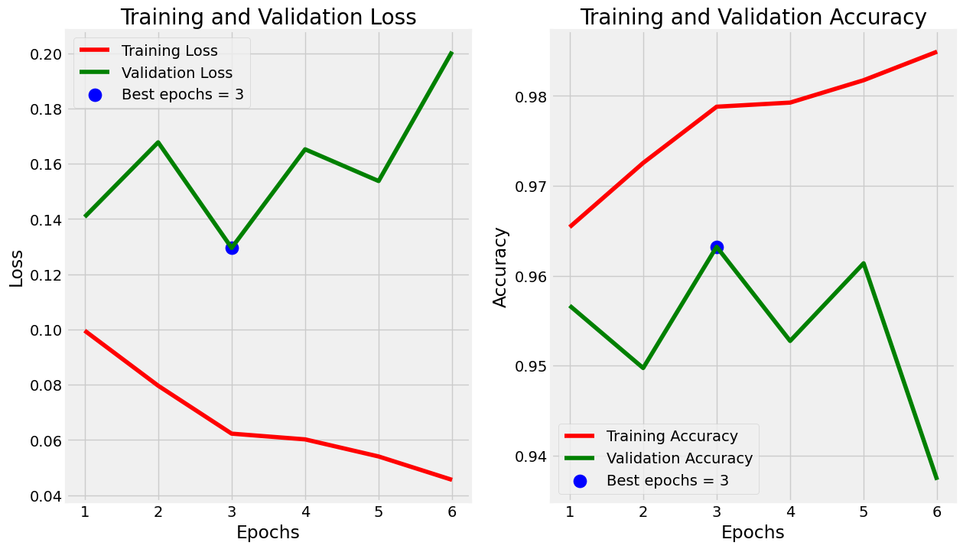
Figure 12. The figure shows the training and loss curves for the model

Feature Importance and Visualization

Confusion Matrix
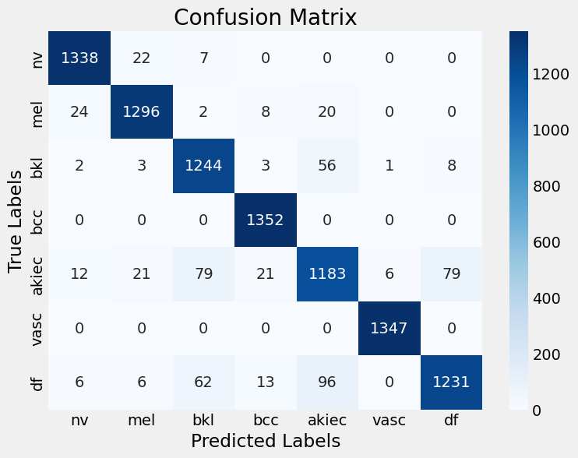
Figure 13. The figure represents a Confusion matrix for the skin cancer model.
The overall performance of the model demonstrates high accuracy, as evidenced by the significantly larger diagonal elements in the confusion matrix, representing correct classifications, compared to the off-diagonal elements(see Figure 13). This indicates the model’s strong ability to accurately classify skin lesions. Furthermore, the model maintains a good balance between precision, which measures the correct identification of positive cases, and recall, which assesses the identification of all positive cases.
On a class-wise level, the model performs exceptionally well for certain categories. For nevi (nv), the classification is highly accurate, with very few false positives and negatives. Melanoma (mel) is also well-classified, though some instances are misclassified as benign keratosis-like lesions (bkl). Similarly, benign keratosis-like lesions (bkl) are accurately identified, though there are occasional misclassifications as basal cell carcinoma (bcc) and actinic keratosis (akiec).
For basal cell carcinoma (bcc), the model exhibits excellent performance with minimal errors. The classification of actinic keratosis (akiec) is generally good but includes some misclassifications as bkl and bcc. Vascular lesions (vasc) are classified with remarkable accuracy, with almost no errors. Lastly, dermatofibroma (df) is also classified with high precision, with only a few instances of misclassification. Overall, the model shows strong performance across most classes, with room for improvement in handling specific challenging categories.

Discussion

Clinical Implications

From the results of this study it is evident that the integration of AI, particularly deep learning models such as Convolutional Neural Networks (CNNs), has immense potential to improve decision-making and early detection in dermatology. AI-based systems can aid clinicians in identifying skin cancer, including melanoma, basal cell carcinoma, and squamous cell carcinoma, by automating the analysis of dermoscopic images. Studies have shown that AI models, especially CNNs, can match or even outperform dermatologists in terms of diagnostic accuracy. This capability can significantly reduce diagnostic errors, ensure more accurate identification of high-risk lesions, and ultimately improve patient outcomes. AI's role extends beyond just diagnosis; it can also facilitate personalized treatment planning by detecting subtle changes in skin lesions that might otherwise go unnoticed, allowing for earlier and less invasive interventions.

Integration into USA Healthcare Systems

AI models can streamline work flows in dermatology by assisting primary care providers (PCPs) in making quicker, more accurate decisions. This integration of AI into routine clinical practice, such as the use of AI-enabled devices like DermaSensor, represents a shift towards more accessible and efficient care. DermaSensor, approved by the FDA, exemplifies how AI can be used to extend diagnostic capabilities to non-specialists, providing accurate skin cancer assessments in primary care settings. This reduces the burden on dermatologists, especially in under-served regions where access to specialists is limited. However, challenges remain in terms of integrating these tools into existing healthcare work flows and ensuring their widespread adoption.

Training clinicians to use AI-assisted tools remains a significant barrier. While AI can support decision-making, it does not replace the need for human expertise. Thus, continuous medical education will be crucial to ensure that healthcare professionals are comfortable with AI models and understand their potential and limitations. There is also a need for robust regulatory frameworks to ensure that AI devices remain effective and safe post-deployment.

Challenges and Limitation

The integration of AI into clinical practices brings significant ethical concerns, particularly regarding transparency and patient privacy. For AI algorithms to be trusted in clinical settings, they must be interpretable, ensuring that decisions are based on clear and understandable reasoning. Patient data used to train these models must be handled with the utmost care to comply with privacy regulations, such as HIPAA in the USA, to protect sensitive information and maintain patient confidentiality. Additionally, robust mechanisms must be in place to prevent data misuse or unauthorized access, addressing concerns about privacy and data security.

One of the key limitations in AI for skin cancer detection is the issue of generalization across diverse populations. Many datasets used to train models, such as CNNs, are often not fully representative of all skin types, particularly under-represented demographics such as individuals with darker skin tones. This lack of diversity can result in reduced accuracy and reliability in detecting skin cancer in these populations, limiting the practical utility of AI in real-world clinical settings. To overcome this challenge, it is crucial to train models on diverse datasets that include a wide range of demographic, geographic, and genetic backgrounds. Collaborations with healthcare institutions can facilitate access to anonymized data from different regions, enhancing the model's ability to generalize and perform reliably across varied populations.

Future Research Directions

Future research in AI-driven skin cancer detection should prioritize expanding datasets and exploring multimodal approaches to enhance model generalizability and diagnostic precision. Larger and more diverse datasets, encompassing a broader range of skin types, demographics, and environmental factors, are critical for ensuring that AI models can generalize effectively across varied populations. This expansion would address existing biases and improve the applicability of these models in real-world, diverse healthcare settings.

Additionally, integrating multimodal data, such as clinical notes, patient history, and genomic information, offers a promising direction. Combining dermoscopic images with comprehensive patient data allows for a more holistic diagnostic approach. This integration not only enhances the accuracy of predictions but also enables personalized treatment recommendations, tailoring interventions to individual patient needs. These advancements would significantly contribute to the reliability and inclusivity of AI systems in skin cancer detection, aligning them with the goals of precision medicine.

Impact on the USA Healthcare System

Enhanced Diagnostic Accuracy and Early Detection
AI, especially CNN models, plays a transformative role in improving diagnostic accuracy in healthcare settings, including dermatology. By automating the analysis of medical images, such as dermoscopic photos for skin cancer detection, AI can identify early signs of malignancy that might be missed by the human eye. These systems enhance the speed and reliability of diagnoses, enabling earlier interventions and better patient outcomes. CNNs, in particular, have shown great promise in detecting skin cancer at earlier stages, thus improving survival rates and reducing treatment costs .

Reduction in Diagnostic Errors
AI's consistency and objectivity help reduce diagnostic errors in healthcare, particularly in fields like dermatology, where visual assessments can be subjective. By providing a second layer of analysis, AI ensures that no critical features are overlooked. This has been demonstrated in studies where AI-driven tools helped identify lung cancer and skin cancer lesions that clinicians might have missed, offering a second chance for early diagnosis.

Efficiency in Clinical Workflows
The integration of AI into clinical workflows streamlines operations by automating administrative tasks and aiding clinicians in decision-making. For example, AI tools in dermatology can quickly process large datasets of medical images, providing dermatologists with efficient diagnostic support. AI also helps optimize resource utilization in hospitals by automating scheduling and managing patient information, thus reducing clinician workload and improving patient care efficiency .

Cost-Effectiveness
Early detection powered by AI can significantly reduce healthcare costs by preventing the progression of diseases. For skin cancer, detecting tumours at an early stage avoids expensive treatments such as chemotherapy or extensive surgeries. Furthermore, AI systems improve the efficiency of healthcare delivery, reducing administrative costs and minimizing waste, contributing to overall cost savings in the healthcare system .

Personalized Treatment Plans
AI enables the development of personalized treatment plans by analysing individual patient data, including medical history and response to past treatments. This capability leads to more precise, effective interventions tailored to the unique needs of each patient. In dermatology, AI tools can guide treatment decisions by identifying the specific type and severity of skin cancer, ensuring the patient receives the most appropriate care for their condition.
AI's integration into the USA healthcare system has the potential to revolutionize patient care by enhancing diagnostic accuracy, reducing errors, improving efficiency, and cutting costs. As AI technologies continue to evolve, their role in healthcare will only grow, leading to more personalized, timely, and cost-effective treatments for patients. However, challenges such as clinician training and the ethical use of AI will need to be addressed for widespread adoption.
Conclusion
This study has observed that AI-based models, primarily CNNs, can be employed to optimize the screening and diagnosis of skin cancer in the USA.This research also demonstrates the significant potential of Convolutional Neural Networks (CNNs) in advancing skin cancer detection, achieving a remarkable test accuracy of 94.17% and effectively distinguishing various skin cancer types from dermoscopic images. These findings highlight the significance of automated feature extraction and class balancing in addressing diagnostic challenges, particularly for under-represented cancer categories.
The integration of deep learning models in healthcare offers profound implications, including reducing diagnostic errors, improving consistency, and expediting decision-making processes, especially in regions with limited dermatological expertise. As AI continues to evolve, its role in enhancing skin cancer diagnosis and treatment is poised to expand, fostering earlier detection, personalized care, and improved patient outcomes. Future advancements in data diversity, model transparency, and multimodal approaches will be instrumental in further optimizing AI-driven diagnostics and transforming dermatological care.

References

AHA. (2024). How AI Is Improving Diagnostics, Decision-Making and Care. American Hospital Association. https://www.aha.org.

JAMA Network. (2024). Cost-effectiveness of Artificial Intelligence as a Decision-Support System Applied to the Detection and Grading of Melanoma, Dental Caries, and Diabetic Retinopathy. JAMA Network Open. https://jamanetwork.com.

Thoughtful AI. (2024). AI in Healthcare: Improving Accuracy and Reducing Costs. Thoughtful.ai. https://www.thoughtful.ai.

MDPI. (2024). Naturalize Revolution: Unprecedented AI-Driven Precision in Skin Cancer Classification Using Deep Learning. MDPI. Retrieved from https://www.mdpi.com.

IEEE Xplore. (2024). Medical Image Analysis Using Deep Convolutional Neural Networks. IEEE Xplore. https://ieeexplore.ieee.org.
Science Publishing Group. (2024). Optimizing CNN Kernel Sizes for Enhanced Melanoma Classification in Dermoscopy Images. Science Publishing Group. https://www.sciencepublishinggroup.com.
Islam, M. Z., Nasiruddin, M., Dutta, S., Sikder, R., Huda, C. B., & Islam, M. R. (2024). A Comparative Assessment of Machine Learning Algorithms for Detecting and Diagnosing Breast Cancer. Journal of Computer Science and Technology Studies, 6(2), 121-135.

Bhowmik, P. K., Miah, M. N. I., Uddin, M. K., Sizan, M. M. H., Pant, L., Islam, M. R., & Gurung, N. (2024). Advancing Heart Disease Prediction through Machine Learning: Techniques and Insights for Improved Cardiovascular Health. British Journal of Nursing Studies, 4(2), 35-50.

Dutta, S., Sikder, R., Islam, M. R., Al Mukaddim, A., Hider, M. A., & Nasiruddin, M. (2024). Comparing the Effectiveness of Machine Learning Algorithms in Early Chronic Kidney Disease Detection. Journal of Computer Science and Technology Studies, 6(4), 77-91.

Nasiruddin, M., Dutta, S., Sikder, R., Islam, M. R., Mukaddim, A. A., & Hider, M. A. (2024). Predicting Heart Failure Survival with Machine Learning: Assessing My Risk. Journal of Computer Science and Technology Studies, 6(3), 42-55.

Bortty, J. C., Bhowmik, P. K., Reza, S. A., Liza, I. A., Miah, M. N. I., Chowdhury, M. S. R., & Al Amin, M. (2024). Optimizing Lung Cancer Risk Prediction with Advanced Machine Learning Algorithms and Techniques. Journal of Medical and Health Studies, 5(4), 35-48.

Al Amin, M., Liza, I. A., Hossain, S. F., Hasan, E., Haque, M. M., & Bortty, J. C. (2024). Predicting and Monitoring Anxiety and Depression: Advanced Machine Learning Techniques for Mental Health Analysis. British Journal of Nursing Studies, 4(2), 66-75.

Alam, S., Hider, M. A., Al Mukaddim, A., Anonna, F. R., Hossain, M. S., khalilor Rahman, M., & Nasiruddin, M. (2024). Machine Learning Models for Predicting Thyroid Cancer Recurrence: A Comparative Analysis. Journal of Medical and Health Studies, 5(4), 113-129.

Rahman, A., Karmakar, M., & Debnath, P. (2023). Predictive Analytics for Healthcare: Improving Patient Outcomes in the US through Machine Learning. Revista de Inteligencia Artificial en Medicina, 14(1), 595-624.

Hider, M. A., Nasiruddin, M., & Al Mukaddim, A. (2024). Early Disease Detection through Advanced Machine Learning Techniques: A Comprehensive Analysis and Implementation in Healthcare Systems. Revista de Inteligencia Artificial en Medicina, 15(1), 1010-1042.

Hossain, M. S., Rahman, M. K., & Dalim, H. M. (2024). Leveraging AI for Real-Time Monitoring and Prediction of Environmental Health Hazards: Protecting Public Health in the USA. Revista de Inteligencia Artificial en Medicina, 15(1), 1117-1145.

